Title: Guidelines for iPolymorphs Abstract

Presenting author's name (e.g. John Smith)¹, Second author's name², ...
¹First author's affiliation, City, Zip code, Country; ²Second author's affiliation, City, Zip code, Country; ...
E-mail: Corresponding Author's e-mail address

The abstract should be written in English and within two page limit. Please follow the format and style (line spacing, margins, fonts etc.) according to this template.
Please use A4 (210 mm x 297 mm) paper size. A maximum of two figures per abstract are allowed.

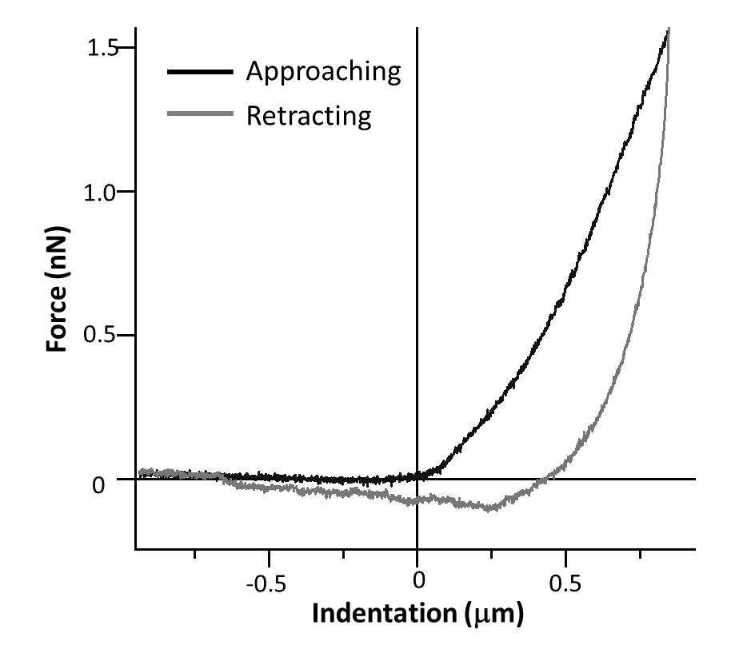
Figure 1. Force versus indentation curves measured at 125 degree C.

References:
[1] J. Smith et al., Science 343, 343 (2014).

Bibliography
[1] A. B. Johnson, Journal, vol, pages (year)

